CHAPTER 6: The Earth in space
Worksheet 6.3

Eclipses
Science Quest 7: pages 223–225
Student: Class:

Solar eclipse
1. The following photograph shows a total solar eclipse.
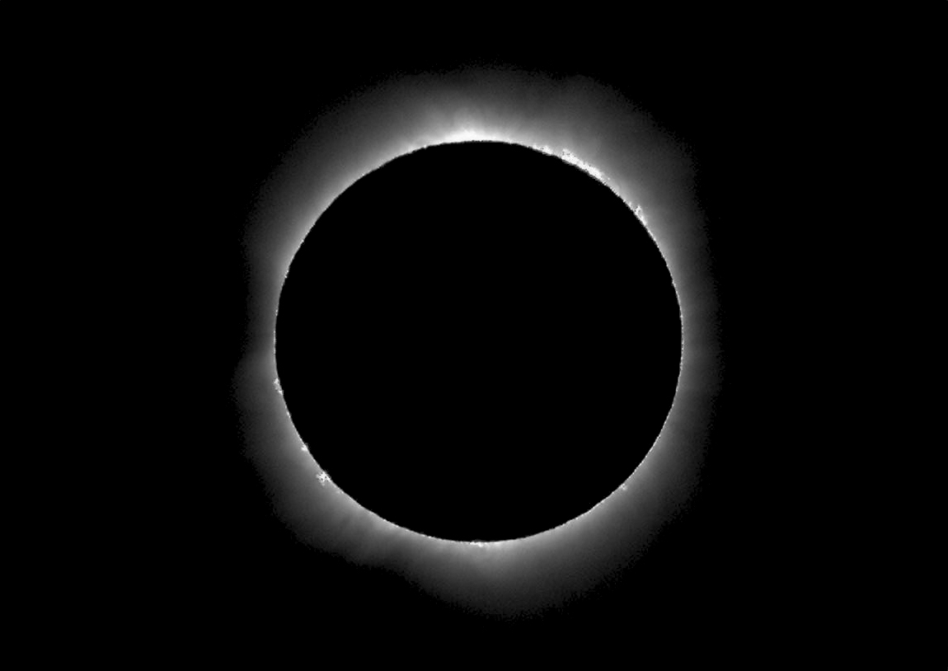  © Newspix/AFP photo/ Torsten Blackwood  Total solar eclipse | Partial solar eclipse

(a) Explain how such an eclipse can occur.

(b) What part of the sun can now be seen?
(c) Draw the image of the sun in a partial solar eclipse.
(d) Explain why total solar eclipses can occur only when there is a new moon. Use a labelled diagram as part of your answer.

Lunar eclipse
2. The following ray diagram is incomplete.
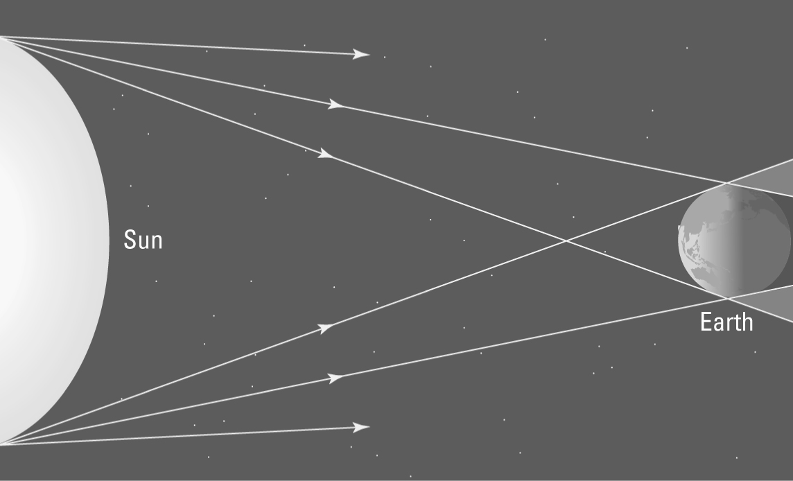 | (a) Using a ruler and pencil, extend the rays of light from the sun past the Earth to create the shadow zones.  (b) Draw in the position of the moon when a total lunar eclipse occurs.  (c) Shade and label the shadow zones called the umbra and penumbra.

